Softball

Equipment:

Balls

Despite the sport's name, softballs are not especially soft. The size of the ball varies according to the classification of play. A 12-inch circumference ball is generally used in slow pitch. Some balls have a raised seam, and others do not. The ball is most often covered in white or yellow leather in two pieces roughly the shape of a figure-8 and sewn together with red thread, although other coverings are permitted. The core of the ball may be made of long fiber kapok, or a mixture of cork and rubber, or a polyurethane mixture, or another approved material.

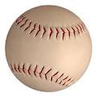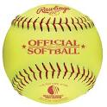

Bats
The bat used by the batter can be made of wood, aluminum, or composite materials such as carbon fiber. Sizes may vary but they may be no more than 34 inches (86 cm) long, 2.25 inches (6 cm) in diameter, or 38 oz. (1.2 kilograms) in weight. The standard bat barrel diameter for both slowpitch and fastpitch softball is 2¹⁄₄ inches. Many players prefer a smaller barrel, which reduces weight and allows higher swing speed.

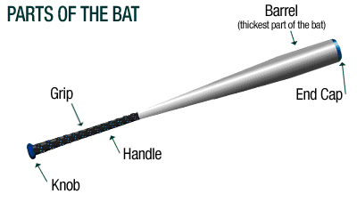

Gloves

All defensive players wear fielding gloves, made of leather or similar material. Gloves have webbing between the thumb and forefinger, known as the "pocket". The first baseman and the catcher may wear mitts; mitts are distinguished from gloves in that they have extra padding, and no fingers. No part of the glove is allowed to be the same color as that of the ball, including that of its seams. Gloves used in softball are usually larger than the ones used in baseball.

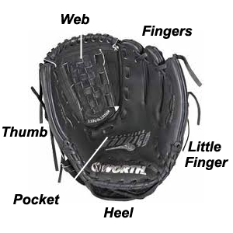

Field of Play/Positions
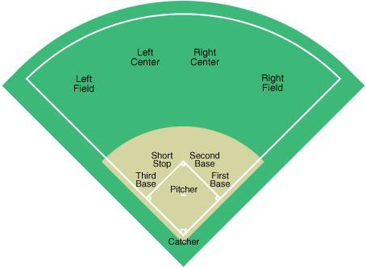

A ROVER (any of the outfield positions) is a player who can be utilized as either an infielder or outfielder (i.e. they can move to the infield and be an infielder, or move to the outfield and be an outfielder). This depends on the team's own defensive strategy.
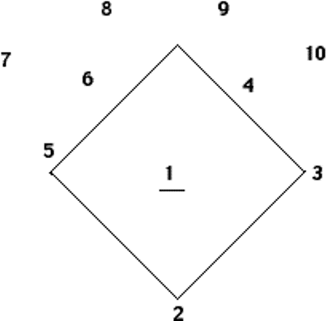
1. Pitcher
2. Catcher
3. 1st Base
4. 2nd Base
5. 3rd Base
6. Shortstop
7. Left Field
8. Left Centre Field
9. Right Centre Field
10. Right Field

Pitcher
The pitcher is the individual who throws the ball from the middle of the diamond or the pitcher's mound. In baseball, the mound is elevated, but in softball the mound is not elevated. The pitcher usually throws the ball in the strike zone. In softball, the pitcher uses an underarm motion to pitch the ball towards the strike zone. As soon as the pitcher makes a throw, the fielders are ready to field balls that are hit in the middle of the diamond. Pitchers usually tend to be tall, very flexible and have good upper body strength. Pitchers can be righthanded or lefthanded.
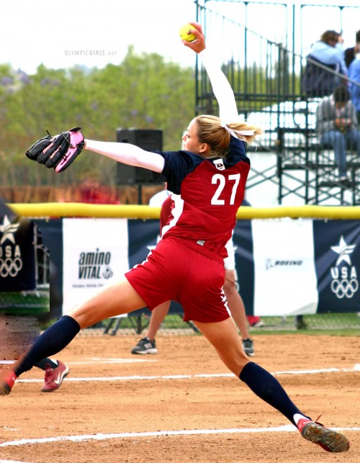

Catcher
The catcher is always behind the hitter in semi-crouched position at home plate. The catcher recovers pitches from the pitcher. The catcher also throws balls to other bases to throw out runners. At home plate, the catcher is responsible for making some of the team's outs by retiring base runners attempting to score. Catchers are usually very strong, agile, think fast and possess fast reflexes. Catchers need a lot of muscle to make powerful and fast throws. They are one of the most important players in the game. Catchers rule the field; they control the plays and tell everyone where to be and when to be there. They are most likely the team captain or share the responsibility with the pitcher.

First baseman
The first baseman is the position to the right of the first base. The major role of the first baseman is to make fielding plays on all balls hit towards first base. The first base is usually involved in every hit that occurs on the playing field. Individuals at first base have quick hands and a good reach. First basemen can be both left and right handed.
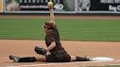

Second baseman
The second baseman plays in between the first baseman and the gap at second. If the ball is hit to the left side of the field, second covers second base. If the ball is hit on their side of the field, they back up the fielder, cover first, or field the ball depending on where it is hit. The second baseman also is the cut off on balls hit to the right side of the outfield. The second baseman also throws directly to the catcher to prevent runners from scoring. Mostly, when the ball is hit to the left side of the field, the second basemen plays second for shortstop.
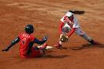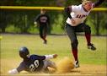
Shortstop
The shortstop fields all balls hit to the infield between the second and third bases. This individual also helps cover second base and is frequently involved in force plays, double plays and frequently throws the ball to the catcher to throw out runners at home plate. Most short stops are very quick, agile and think fast. Shortstops may play in a restricted zone but are faced with many types of hits and interact closely with the 2nd base, 3rd base and home plate. Often double plays are due to quick thinking by the short stop. Short stop also takes the cut off for the left field when the play is at second base. When the ball is hit to the right side of the outfield, the short stop then covers second base. Shortstop is one of the most difficult positions to play due to the amount of balls being hit in that direction.

Third baseman
The third baseman covers all hits to the third base and receives balls from the outfield. The third base person also frequently throws the ball to the catcher trying to throw out the runner at home plate. The individual at third base usually thinks fast because of the types of hits that commonly occur in that zone. Quick thinking can often stop runners from scoring or can result in double plays.
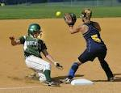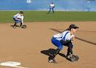
Outfielders
The outfielders are players that cover the grassy area behind the infield. Outfielders are named for their positions in the field relative to home plate. Traditional outfield positions include a left fielder, a center fielder, and a right fielder. These players usually back up the plays made by the infielders and make plays when the ball is hit past or over the infield. Because their positions cover a greater range than those of infielders, outfielders tend to have strong throwing arms. Outfielders are responsible for throwing fielded balls to a player known as a cut-off person (usually a second baseman or short stop). In this way, the outfielders more efficiently return the ball to the infield with the goal of preventing base runners from advancing to additional bases. In some leagues/ organizations, four outfield players are utilized by each team, with the center field position being shared between two players known as the left-center fielder and the right-center fielder.
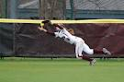

Batters
The offensive team sends one "batter" at a time to home plate to use the bat to try to hit the pitch forward into fair territory. The order the players bat in, known as the "batting order", must stay the same throughout the game. Substitutes and replacements must bat in the same position as the player they are replacing. In co-ed, male and female batters must alternate.
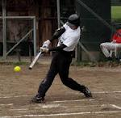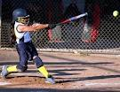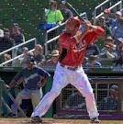
Game Play
The playing field is divided into 'fair territory' and 'foul territory'. Fair territory is further divided into the 'infield', and the 'outfield', and the territory beyond the outfield fence.
The field is defined by 'foul lines' that meet at a right angle at 'home plate'. The minimum length of the baselines varies classification of play. A fence running between the baselines defines the limits of the field; this fence is equidistant from home plate at all points.
Behind home plate is a 'backstop'. It must be between 25 and 30 feet (7.62 and 9.14 meters) behind home plate depending on the type of division that is playing.
'Home Plate' is one corner of a diamond with 'bases' at each corner. The bases other than home plate are 15 in (38 cm) square, of canvas or a similar material, and not more than 5 in (13 cm) thick. The bases are usually securely fastened to the ground. The bases are numbered counter clockwise as first base, second base, and third base. Often, but not always, outside first base (that is, in foul territory) and adjacent and connected to it there is a contrast-colored "double base" or "safety base". It is intended to prevent collisions between the first baseman and the runner. The runner runs for the foul portion of the double base after hitting the ball while the fielding team tries to throw the ball to the regular first base before the runner reaches the safety base.
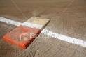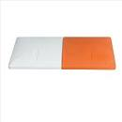
The infield consists of the diamond and the adjacent space in which the infielders normally play. The outfield is the remaining space between the baselines and between the outfield fence and the infield. The infield is usually "skinned" (dirt), while the outfield has grass in regulation competitions.
Near the center of the diamond is the pitching plate.
A field is officially supposed to have a warning track between 15 and 12 feet (5 and 4 meters) from the outfield fence. However, if the game is being played on a field larger than required, no warning track is required before the temporary outfield fencing.

Softball is played between two teams on a large field, with 10 players from one team on the field at a time. The field is usually composed of a dirt or brickdust infield which contains the quadrilateral shape and running areas, and a grass outfield. There are 4 bases on the infield (first base, second base, third base,and home plate); the bases are arranged in a square and are typically 45 to 65 feet (13,7 to 19,8 meters) apart. Near the center of this square is the pitcher's circle, and within the circle is the "rubber", a small flat rectangular piece of rubber about a foot and a half in length. The rubber can be 40 or 43 feet away from home plate, depending on age level and also the league one is playing in.
The object of the game is to score more runs (points) than the other team by batting (hitting) a ball into play and running around the bases, touching each one in succession. The game is officiated by one or more neutral umpires. Players and umpires are generally free to ask for a brief stoppage at any time when the ball is not in play, or immediately following a play once its outcome is clear.
The game is played in a series of innings, usually seven. Some play with a time limit(around 150 minutes). Youth leagues sometimes have 6 innings. An inning is one series of both teams playing offense and defense. Each inning is divided into a top half and a bottom half indicating which team is playing which role. The offense bats and attempts to score runs, while the defense occupies the field and attempts to record outs in a variety of ways. After the defense records 3 outs, the half inning is over and the teams switch roles.
To start play, the offense sends a batter to home plate. The batting order must be fixed at the start of the game, and players may not bat out of turn.
The defense's pitcher stands atop the rubber and throws the ball towards home plate using an underhanded motion. The batter attempts to hit the pitched ball with a bat. A pitch must fly over plate within an area known as the strike zone, which is the area between the knees, and the logo. The strike out zone therefore varies from batter to batter, and the umpire behind home plate is the sole arbiter of what is or is not a valid catch. A pitch which does not cross the strike zone is a ball, and if the batter reaches 4 balls, the batter is awarded the first base. A pitch which crosses the strike zone is a strike, and a batter who reaches 3 strikes is out (a strikeout), and the next batter in the order comes to bat. A strike is also recorded on any pitch that the batter swings at and misses entirely, and also on a pitch that is hit foul (out of play). A foul ball may or may not result in a strikeout dependent upon what association and local league rules.
The batter attempts to swing the bat and hit the ball fair (into the field of play). After a successful hit the batter becomes a baserunner (or runner) and must run to first base.
Base Runner
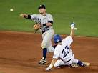
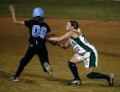
The defense attempts to field the ball and may throw the ball freely between players, so one player can field the ball while another moves to a position to put out the runner. The defense can tag the runner, by touching the runner with the ball while the runner is not on a base. The defense can also touch first base while in possession of the ball; in this case it is sufficient to beat the batter to first base and an actual tag of the batter is unnecessary. A runner is said to be thrown out when the play involves two or more defensive players. Runners generally cannot be put out when touching a base, but only one runner may occupy a base at any time and runners may not pass each other.
Thrown Out
Tagged Out
When a ball is batted into play, runners generally must attempt to advance if there are no open bases behind them; for example, a runner on first base must run to second base if the batter puts the ball in play. In such a situation, the defense can throw to the base that the lead runner is attempting to take (a force out), and the defense can then also throw to the previous base. This can result in a multiple-out play: a double play is two outs, while a triple play, a very rare occurrence, is three outs. Runners with an open base behind them are not forced to advance and do so at their own risk; the defense must tag such runners directly to put them out rather than tagging the base.
A ball which is hit in the air and caught before hitting the ground is an immediate out, regardless of whether the ball would have landed fair or foul. A fly ball is a ball hit high and deep, a pop fly is a ball hit high but short, and a line drive is a ball hit close to the horizontal. In any such situation, runners must remain on their bases until the ball is touched by a defensive player or hits the ground. If a runner leaves the base before a fly ball, pop fly, or line drive is touched or contacts the ground, the defense can throw the ball to that base, and if the base is tagged before the runner returns, the runner is out as well, resulting in a double play. If the runner remains on the base until the ball is touched, or returns to the base after the catch but before the defense can put him out, he is said to tag up and may attempt to advance to the next base at his own risk. If there are less than two batters out and runners on 1st and 2nd bases and the batter hits a pop fly in the infield, the batter is automatically out to prevent unfair play by the fielders. Unfair play may result from infielders deliberately dropping the ball to try and achieve a double play. This rule is called the infield fly rule.
Line Drive
Fly Ball
Offensive strategy is fairly straight forward, revolving around hitting the ball to let the batter reach base safely and to advance the base runners towards home plate to score runs.
Defensive strategy can be more complex, with particular situations calling for different positioning and tactical decision making. For both sides, there can be a trade-off between outs and runs: the offense can sacrifice a batter to advance runners, while the defense may allow a runner to score if the remaining runners can be put out in a double play.

Playing the Game
A softball game can last anywhere from 3 to 9 innings, depending on the league, rules, and type of softball; however 7 innings is the most common. In each inning, each team bats until three batters have been put out. The teams take turns batting. Officially, which team bats first is decided by a coin toss, although a league may decide otherwise at its discretion. The most common rule is that the home team bats second. Batting second is advantageous.
In the event of a tie, extra innings are usually played until the tie is broken. In all forms of softball, the defensive team is the fielding team; the offensive team is at bat or batting and is trying to score runs.

Links to Videos of the Skills you will need!
www.youtube.com/watch?v=84V324Mx7RA
www.youtube.com/watch?v=7Aihc9_-GYU
www.youtube.com/watch?v=KoXYP2U4q7U
www.youtube.com/watch?v=2rRgMKyJCcY

